 **Parish of St Wilfrid**

**Lent 2025**

**Ash Wednesday – 5th March**

7am – Holy Mass at St. Bede

9.30am – Holy Mass at St. Basil

12noon – Holy Mass at St. Michael

7pm – Holy Mass at St. John Fisher

**Scripture Group – Jubilee of Hope**

Tuesday 11th March

Tuesday 18th March

Tuesday 25th March

Tuesday 1st April

Tuesday 8th April

Tuesday 15th April

***These sharing sessions on the Scriptures will take place after the 12noon Mass at St. John Fisher and will be led by Anne Skilki.***

***Come along, it is a beautiful way to know who Jesus is!***

**Taize Prayer – ‘All who are thirsty…come’**

Tuesday 11th March at 7pm at St. Basil

*Led by the Music Ministry at St. Basil*

**Early Riser Mass at 7am**

Wednesday 12th March

Wednesday 19th March

Wednesday 26th March

Wednesday 2nd April

Wednesday 9th April

***These will take place at St. John Fisher***

**Holy Hours during Lent**

Monday 17th March at St. John Fisher – Jesus, the Healer

Monday 31st March at St. Basil – Jesus, the Word Made Flesh

Monday 7th April at St. Michael – Jesus, the Comforter

***These Holy Hours will be led by our Clergy Team and will start at 7pm.***

**CAFOD – Soup and Prayer**

Thursday 10th April, 7pm at St. John Fisher Hall

**Lenten Confessions**

Saturday 12th April at 10am at St. Basil

**Lenten Reconciliation Service**

Tuesday 15th April at 7pm at St. John Fisher

**Stations of the Cross**

Monday 10th March at 7pm at St. Basil

Monday 14th April at 7pm at St. John Fisher

**Walk of Witness – Palm Sunday, Sunday 13th April**

3pm starting at St. Bede, walking through Victoria Park

**Easter Lilies**

Would you like to buy a lily for Easter? These flowers are often bought in memory of a loved one and their names are displayed in each of the Churches for the Sacred Triduum and Easter Sunday. **There will be envelopes and forms at the back of all churches that should be completed and returned to the Parish Office before Friday 11th April.** A lily is £5 each.

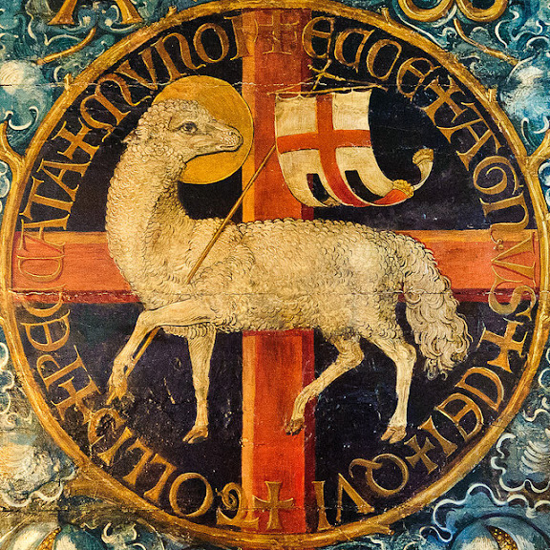

**TRIDUUM**

**Maundy Thursday – 17th April**

7pm – Mass of the Lord’s Supper at St. Michael

8pm – 8.45pm – Watching in the Garden of Gethsemane

8.45pm – Night Prayer

**Good Friday – 18th April**

11am – Children’s Stations of the Cross at St. John Fisher

3pm – Passion of Our Lord and Veneration of the Cross

St. Bede and St. Michael

**Holy Saturday – 19th April**

8.30pm – Vigil of the Resurrection at St. Michael

**Easter Sunday – 20th April**

9am – St. John Fisher

9am – St. Basil

10.15am – St. Michael

10.30am – St. Bede